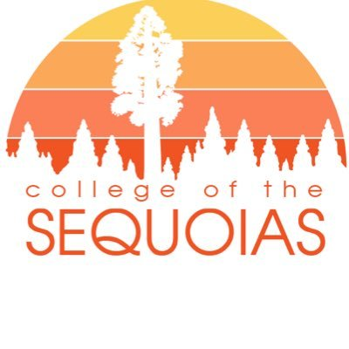

**C O S**

**General Education**

**Committee**

**Agenda**

September 22, 2023

12:00-1:30pm – Zoom:

[**https://cos-edu.zoom.us/j/82747673922?pwd=VStMMGM4aHhPbU11WkRQRk9vMmpCdz09**](https://cos-edu.zoom.us/j/82747673922?pwd=VStMMGM4aHhPbU11WkRQRk9vMmpCdz09)

**Committee Members**

Co-Chairs:

Jesse Wilcoxson (Dean)

Linda Flora (SCI)

Representatives

Josh Muller (SOCS)

Allison Ferry-Abee (AG)

Laura Harris (CFS)

Travis Burkett (PE)

Jennie Garcia (Counseling)

Justin Aceves (LIBR)

Vacant (STU Senate)

Mainou Her (Articulation)

Advisory

Sarah Harris

Meeting Coordinator

Daniel Alvarado

1. Call to Order
2. Comments/Questions
   1. Regarding items on the agenda
   2. Regarding items not on the agenda
3. Unfinished/ Ongoing Business
   1. Approve minutes from August 25, 2023*
   2. Approve Initiatives for 2023 - 2024
   3. FA2024 Requirements for Associate Degree – Update
   4. Draft COS GE Pattern
4. New Business
   1. GE Course Review
   2. Cal-GETC Updates
   3. Accreditation Updates
5. Old Business
6. Adjournment

**\*document included in OneDrive shared folder:** [**https://giantcosedu-my.sharepoint.com/:f:/r/personal/lindaf_cos_edu/Documents/GE Committee 2023.2024/September 22 %2723 Meeting?csf=1&web=1&e=nvkBBp**](https://giantcosedu-my.sharepoint.com/:f:/r/personal/lindaf_cos_edu/Documents/GE%20Committee%202023.2024/September%2022%20%2723%20Meeting?csf=1&web=1&e=nvkBBp)